Smoke and Mirrors Database System

For FogCity Publishing House

CSC 440 Database Systems

Project Report #1

Project Team L (Team Yellow Pants)
Nathaniel Derbinsky, Gourang Mehta, Yi Ding, Timothy Kerchmar

1) Assumptions and Problem Statement

Assumptions

- An issue's articles are not stored in any particular order.
- There is only one publishing house that uses the system.
- Shipping cost and price must be entered in for each order.
- Order cost = shipping cost + price * number of copies.
- There can only be one issue per order and only one distributor per order.
- Payments are instantaneous, as soon as they are entered into the system, they are applied to a distributor’s balance.
- All members of a user class may perform the same operations, there are no per user permissions but there are cases where users can only see their own data.
- Publications must be of just one type.
- A distributor must be of just one type.
- Articles can belong to multiple issues of any number of publications.
- No records are kept that link payments to specific orders.

Problem Statement

The Smoke and Mirrors database will be used for the FogCity publishing house. The database system is going to be used by the management, editors, journalists and the distributors associated with the publishing house. The database will maintain information about publications, issues, articles and distributors. Each of the respective users of the database will have specific tasks and operations that they can perform.

When all the information for a publication's articles and table of contents is managed by the database, there are significant advantages.

- A database provides optimized concurrency with data which means many users can perform various tasks at the same time, such as adding or assigning articles to a publication, and quickly see the results of their work. Databases provide a granular locking scheme, which makes it easier and more probable for many users to perform tasks on the data at the same time.

- The database ensures that no "misunderstandings" cause unexpected problems, by ensuring that users cannot partially update data: either the attempted operation fails entirely or succeeds completely. This is known as transactional support. It does not allow the database to be only half updated which causes errors and inaccuracies to get into the system.

- Databases are optimized for complex queries and searching for specific data, thanks to caching and indexes. It would be faster and more efficient to create reports and search for specific articles using a database.

A plain file system does not make these claims. Files are not transactional, and thus cannot protect against partial updates. Files also provide a single level of locking, accessible by only one process at a time, so when a user opened a file for writing, other users would not be able to access any of that file's information. Given the cooperation required in the publishing house's workflow, a database is the best tool for the job, with its inherently multi-user design.

2) User Classes

We believe that the four tasks listed in the Project Narrative reflect perfectly the four classes of users that our system will need to support.

Managers are users who collect and analyze reports on various aspects of the production and distribution of the publications. Managers are responsible for entering/updating publications and assigning editors to publications. Managers can also view their own personnel information and that of editors/journalists.

Editors manage publications and create the table of contents for a publication, drawing articles from a list of available articles.

Journalists write articles and submit them to the system, so that those articles could be used by publications.

Distributors place orders for issues of publications and can view their account information with the publishing house.

3) The Main Entities

The five entities that are the most relevant to the tasks and operations required by our clients are the following.

Publication – title, editor(s), type (newspaper, journal, magazine), periodicity of publication (daily, weekly, etc), typical topics (e.g., general, sports, technology, etc)

Issue - title, date of issue, articles in the issue, publication

Article - author(s), title, text of the article, date of creation, associated issues, topics

Distributor - name, type (wholesale distributor, bookstore, library), street address, city, phone number, contact person, balance (how much is owed to the publishing house)

Order - distributor, issue, number of copies, date, price, shipping cost

4) A Usage Situation

ESPN approached FogCity Publishing House last week about a new magazine that they want published. It will be a magazine exclusively about rocket sledding, which has recently caught on in parts of Siberia, due to year round snows. After talking with Jack Daniels, President of FogCity, both parties agree on a price and the contract is written up. The senior manager, C. V. Cauntro, adds the new publication, Amateur Rocket Sledding's information to the database, assigning a couple of editors to the new publication.

Bob Bohin, a journalist is asked to write the grand super opening article for this publication. He writes it and adds the new article, "Delights and Disasters: How to Rocket Sled Safely" using the client program for Smoke and Mirrors.

An editor for the January 15th article was going through the new rocket sledding articles that had been created. He was worried by Bob's article, because it declared rocket sledding as "far faster than dog runners could ever dream of", so he retrieved the article from the database, edited out that comment, and updated the article record. His hopes were that some borderline Inuit wouldn't find the article offensive.

5) Application Program Interfaces

Editing & Publishing
newPublication(title, type, periodicity)
return publicationID or NULL for error

updatePublication(title, type, periodicity, publicationID)
return confirmation
- if NULL value for title/type/periodicity, these will not be updated

assignEditor(personID, publicationID, removeBoolean)
return confirmation

addTopic(publicationID, topicID, removeBoolean)
return confirmation

viewEditorPublication(personID)
return list of publications – publicationID, title, type, periodicity

addArticle(articleID, issueID, removeBoolean)
return confirmation of the article added/removed
- removeBoolean
  - True to add article
  - False to remove article

Production of an Issue
createIssue(title, date, publicationID)
return issueID or NULL for error

updateIssue(title, date, publicationID, issueID)
return confirmation
- if NULL value for title/date/publicationID, these will not be updated

deleteIssue(issueID)
return confirmation

enterArticle(title, date, text)
return articleID

updateArticle(title, date, text, articleID)
return confirmation
- if NULL value for title/date/text, these will not be updated

addAuthor(articleID, personID, removeBoolean)
return confirmation
- removeBoolean
  - True to add author
  - False to remove author

addArticleTopic(articleID, topicID, removeBoolean)
return confirmation
- removeBoolean
  - True to add article topic
  - False to remove article topic

findArticle(topicID)
return list of articles – title, date, text

findArticle(date)
return list of articles – title, date, text

findArticle(personID)
return list of articles – title, date, text

Distribution
enterDistributor(name, type, address, city, phoneNumber, contactPerson)
return accountNumber

updateDistributor(name, type, addr, city, phone, contact, balance, acctNum)
return confirmation
- if NULL value for name/type/addr/city/phone/contact/balance, these will not be updated

inputOrder(issueID, accountNumber, date, price, shipping, numCopies)
return orderID

billDistributor(orderID)
return confirmation

receivePayment(amount, distributorID)
return confirmation

Reports
createMonthReport(month, distributorID)
return the number and total price of copies of each publication bought per distributor per month
- If NULL is passed for month, a report for all months is returned
- If NULL is passed for distrubutorID, a report for all distributors is returned

totalRev(date)
return the total revenue of the publishing house
- If NULL value for date, include all records to date

totalExp(date)
return the total expenses of the publishing house
- If NULL value for date, include all records to date

totalPerCity(city)
return total revenue for a city
- If NULL is passed for the city, total revenue for all cities is returned

totalDistributors(date)
return the number of current distributors
- If NULL value for date, include all records to date

6) Data Views

Manager
Since the managers are the people at the top and oversee the whole publishing house operation, in our model it is reasonable to assume the managers deserve the most privilege. To be specific, following are the concrete data the manager shall view:

- The publication tables with title, editor(s), type, periodicity, and topics; the table of issues with title, date, and associated publication
- The table of personnel including editors and journalists with name position, and salary
- The tables of distributors with name, type, address, city, phone, contact, and balance
- The table of orders with issue, publication, date, numbers of copies, price, and shipping costs.
- All the data in all reports including total revenue, total expenses, and others mentioned above.

We don’t think it is necessary for manager to view all the data in the article table, which is supposed to be delegated to editors.

Editor
Editor shall be designed to view all the data relevant to editing an issue. The editor shall see the followings:

- The table of his owned publication: title, editor(s), type (newspaper, journal, magazine), periodicity of publication (daily, weekly, etc), and typical topics;
- The table of associated issue: title, date of issue, articles, publication; the table of articles with detailed data such as author, title, text, date, and issue in which the articles were published; and the table with personnel name and position for editors and journalists.

Journalist
Journalist shall be able to view the data about articles: title, text, date, issue(s), publication and his personnel information.

Distributor
Distributor shall view all data relevant to production and his account. To be specific, he needs to view data in:
- The table of his owned order: date, publication, issue, copies, price, and shipping cost.
- His own information in distributor table with his name, type, address, city, phone, contact, and balance. He also needs to see data about the issue in the order, such as title, date of issue, articles, and publication.

7) Local E/R Diagrams

Manager
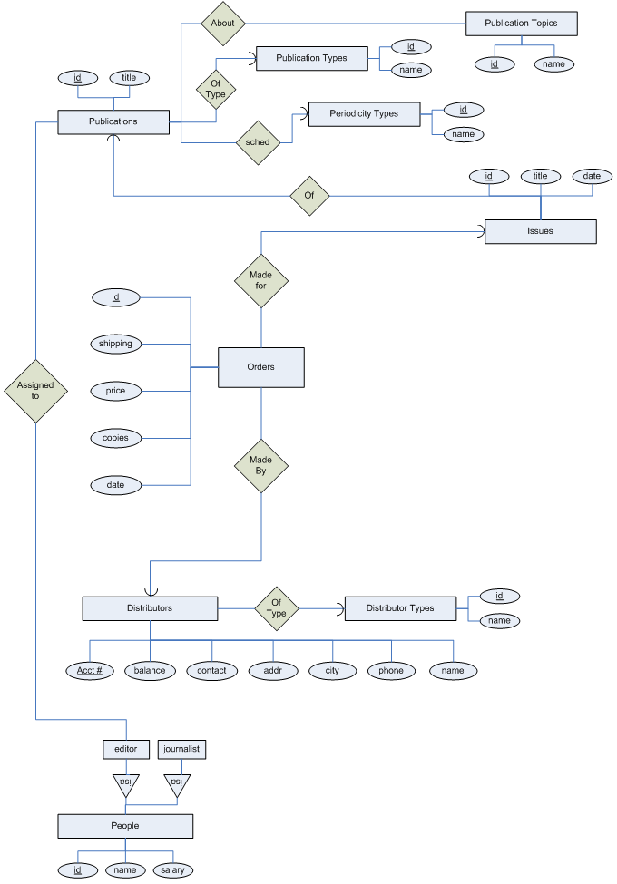
Editor
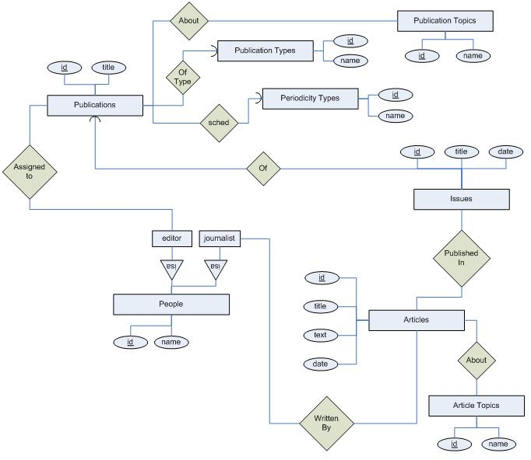

Journalist
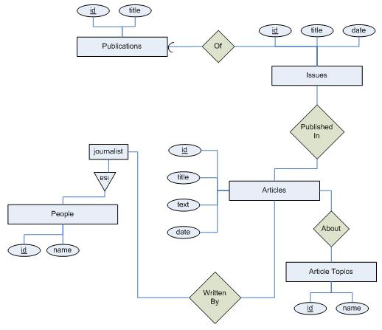

Distributor
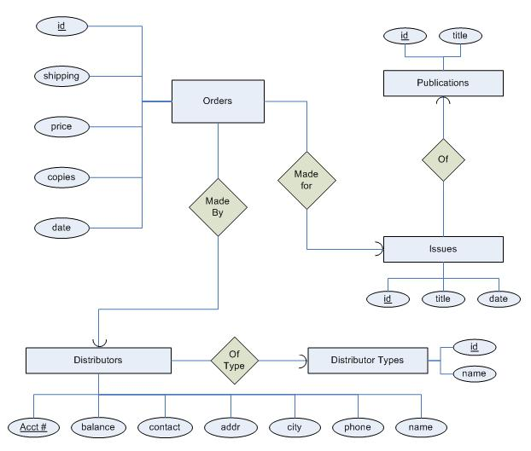

8) Local E/R Documentation

- People working for the publishing house can be managers, editors, and/or journalists.

- We chose to use unique ids as opposed to field keys. Here are the reasons:

- publications: this allows the publishing house in the future to make multiple publications of the same title, type, and periodicity (such as morning/evening newspapers).
- people: this allows for multiple individuals with the same name, position, and salary.
- issues: this allows multiple issues with the same title to be published on the same date.
- articles: this allows multiple articles to be entered on the same date with the same title without having to compare whole texts.
- distributors: the account number will be unique anyway, so was used.
- orders: this allows multiple orders with the same basic information (price, shipping, copies, distributor) to be entered on the same day, which is quite a valid possibility.

  - Publication types, publication periodicities, article topics, and distributor types were made entity sets, rather than attributes, to allow better searching and to reduce redundancies/errors in entering/storing data.

    - We made several decisions regarding relationship types and constraints:

- AssignedTo: editors can be assigned to multiple publications, publications can be edited my multiple editors.
- About: publications can be about multiple topics, topics can apply to multiple publications.
- OfType: each publication has one and only one type, but the same type can apply to multiple publications.
- sched: each publication has one and only one periodicity, but the same periodicity can apply to multiple publications.
- Of: an issue is of one and only one publication, but a publication can have multiple issues.
- PublishedIn: articles can be published in multiple issues, issues can publish multiple articles.
- About: articles can be about multiple topics, topics can apply to multiple articles.
- WrittenBy: articles can have multiple authors, the same author can write multiple articles.
- OfType: distributors are of one and only one type, but the same type can apply to multiple distributors.

- MadeBy: orders are made by one and only one distributor, but the same distributor can make multiple orders.
- MadeFor: orders comprise of one and only one issue, but the same issue can appear in multiple orders.

9) Local Relational Schemas

Manager
people(id, name, salary)
editors(id)
journalists(id)
publication_types(id, name)
periodicity_types(id, name)
publications(id, title, publication_type, periodicity)
publication_assignments(pub_id, editor_id)
publication_topics(id, name)
publications_about(pub_id, topic_id)
issues(id, title, date, pub_id)
distributor_types(id, name)
distributors(acct, balance, contact, addr, city, phone, type, name)
orders(id, shipping, price, copies, date, issue_id, distributor_id)

Editor
people(id, name)
editors(id)
journalists(id)
publication_types(id, name)
periodicity_types(id, name)
publications(id, title, publication_type, periodicity)
publication_assignments(pub_id, editor_id)
publication_topics(id, name)
publications_about(pub_id, topic_id)
issues(id, title, date, pub_id)
articles(id, title, text, date)
article_topics(id, name)
articles_about(article_id, topic_id)
article_authoring(article_id, journalist_id)
article_publication(article_id, issue_id)

Journalist
people(id, name)
journalists(id)
publications(id, title)
issues(id, title, date, pub_id)
articles(id, title, text, date)
article_topics(id, name)
articles_about(article_id, topic_id)
article_authoring(article_id, journalist_id)
article_publication(article_id, issue_id)

Distributor
publications(id, title)
issues(id, title, date, pub_id)
distributor_types(id, name)
distributors(acct, balance, contact, addr, city, phone, type, name)
orders(id, shipping, price, copies, date, issue_id, distributor_id)

10) Local Schema Documentation

Primarily the mechanical approach was used to create the local schemas with a additional judgments, to be addressed later.

- Each entity set was made into a relation with the same set of attributes
- Relationships were replaced by a relation whose attributes are the keys for the connected entity sets

The E/R viewpoint was used to convert the subclasses of the people entity set into relations. This method was used for the following reasons:

- The system can differentiate between journalists, editors, and managers
- All people including journalists, editors, and managers can be referenced from one table which reduces join operations in most reports mentioned above.

Many-to-one relationships were combined with other relations (such as distributor types, periodicity types, etc). Combining relations in this way makes it more efficient to answer queries that involve attributes of one relation than to answer queries involving attributes of several relations.

